**Version Controlling Machine**

**What is Version Control?**

1. A system that keeps record of your changes
2. Allows for collaborative development
3. Allows you to know who made what changes and when.
4. Allows you to revert any changes

**Version Control System types**

Local

Centralised

Distributed

**Local Version Control System :-**

* A local version control system (VCS) is a software tool that helps individuals manage changes to files and documents in a localized manner.
* It allows you to track modifications, create checkpoints, and maintain a history of changes made to a project's files over time.
* This can be particularly useful for managing code projects, documentation, and any other types of files where tracking changes and collaboration are important.
* Eg :- Git

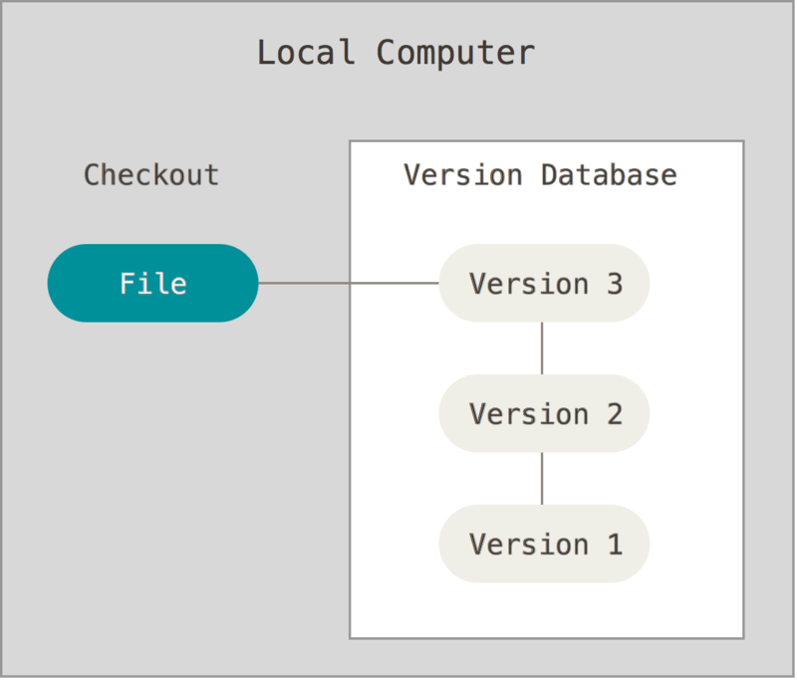

**Centralised Version Control System :-**

* A centralized version control system (VCS) is a type of software that enables multiple users or a team to collaborate on a project by maintaining a central repository that contains all versions of files and documents.
* In a centralized VCS, there is a single, authoritative copy of the project's files located on a central server.
* Developers or team members interact with this central server to access and update files.
* Eg :- SVN

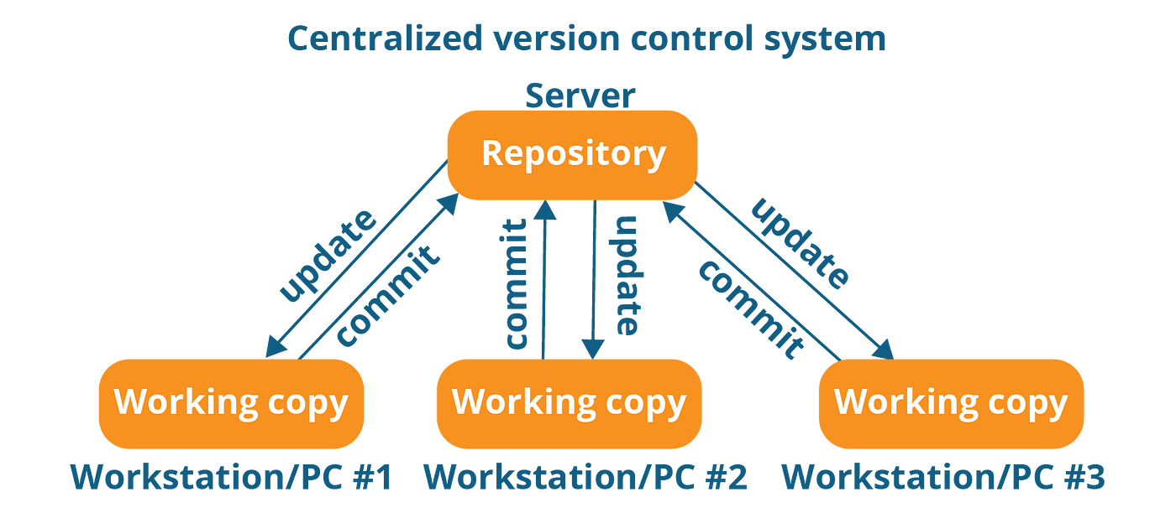

**Distributed Version Control System :-**

* A distributed version control system (DVCS) is a type of software that allows multiple users or a team to collaborate on a project by providing each participant with a full copy of the project's repository.
* Unlike centralized version control systems (CVCS), where there is a single central repository, in a distributed VCS, every user has their own local repository that contains the entire history and version of the project.
* This decentralization offers several advantages and enables more flexible and resilient collaboration.
* Eg :- GitHub , GitLab

